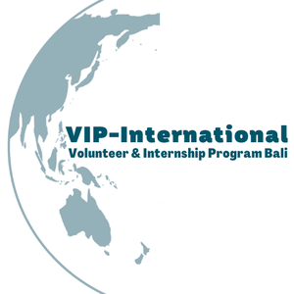

Assessment Form
for
Volunteers and Student Projects

1 Introduction

The purpose of the assessment form is to register you as a Volunteer, and to determine the best placement for you, based on your skills, and preferred options.

- Please read the Information Book for Volunteers, to get a good understanding of the program and the placement locations. You can download this document from our website: https://www.vip-international.net/apply/
- Please fill out the Assessment form and sign it, and send it back to us along with:

- Your resume (in English)
- A copy of your passport.

- After we have received your assessment form, we will then schedule a video call with you to discuss the details, and give you the answers of all your questions, that you might have.
- If you decide to go through with your volunteering, we will sent you all other documents that you need to start your volunteering:

- The VIP International Agreement, including: Terms and Conditions and Code of conduct.
- Documents to apply for your Visa. You will have to apply for a B211A Visa through an authorized Visa Agent in Bali. We can refer you to our Agency in Bali. Please know, we will share your assessment information with our Visa Agency in Indonesia.

Kind regards,
The VIP-International Team

Assessment for volunteers and students
The assessment form
Personal Information
Name
Address
City, State
Zip code / Postal code
Country
Telephone / cell phone
E-mail
Date of Birth
Place of Birth
Country
Passport number
Whom to contact in case of emergency
Name
Address
City, State
Zip code / Postal code
Country
Telephone
Cell Phone
E-mail
Relationship to volunteer
Practical Information:
Do you have experience with voluntary work?
If yes, please specify?

Do you have experience with working with children?
If yes, please specify?

During what period do you wish to volunteer? From what date until what date?

Is your volunteering/internship a part of a program or project from your school?
If yes, which study and which school?

Do you need internship supervision?

Do you need a local practical trainer for your internship?

Do you need an evaluation report of your internship?

What is your motivation to volunteer or do your internship work in Bali?

What kind of activities do you want to do with to the children? About what subjects?

What are your personal goals for doing voluntary work/internship with the WINS foundation?

What are your expectations while volunteering/internship with the WINS foundation?

Do you speak the Indonesian language?

VIP-International can assign you to one or more of the following WINS sites:
Bali:
- Bedulu
- Seraya,
- Samsaman.

Do you prefer a specific site?
(Where possible, WINS will assign you to the site of your preference.)

Do you want to stay at the guestroom at the Learning Center?
(Mandatory at the Yayasan Widya Guna).

Do you already have a B211A visa?  (Mandatory to volunteer or do an internship.) | Note: You will have to apply for a B211A visa through an authorized Visa Agent. We can refer you to our Agent in Bali.
Please attach:
- Your resume in English
- A good quality copy of your passport

And please send these to: mailto:info@vip-international.net

Date:

Place:

Signature: ………………………………….

